

Selecting a donor population of propagated freshwater pearl mussels (Margaritifera margaritifera) for conservation reinforcement when a local population is critically low
A partnership project.
Co-funded by the European Union.

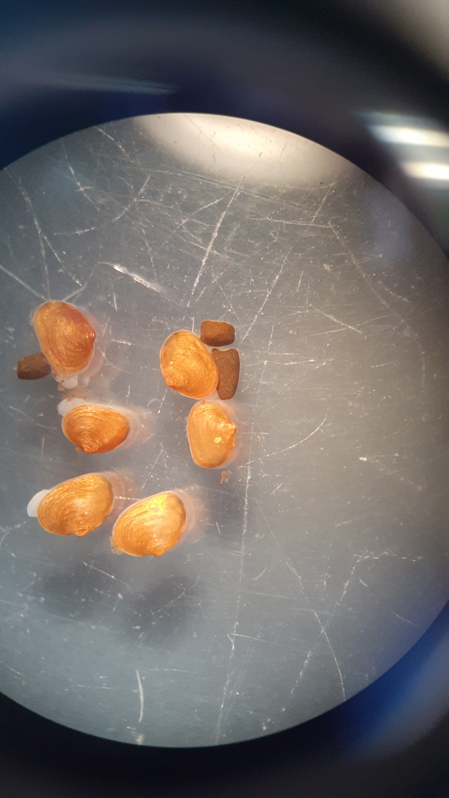
A Best-Practice Guide



Samantha Bonny, Louise Lavictoire, Jodie Warren, Ben King, Yasmin AliEskandari, Kathrine Andrews

May 2025

Research Contractor
This document was produced by the Freshwater Biological Association.
Authors and contributors: Samantha Bonny, Louise Lavictoire.
Citation
Bonny, S., Lavictoire, L. Warren, J., King, B., AliEskandari, Y., Andrews, K. (2025). Selecting a donor population of propagated freshwater pearl mussels (Margaritifera margaritifera) for conservation reinforcement when a local population is critically low. Unpublished report to LIFE R4ever Kent.
Project Funders
This project is funded by LIFE.
LIFE R4ever Kent will restore and revitalise the River Kent SAC and its wider catchment, so it is more resilient to environmental pressures. Freshwater pearl mussel (FPM) (S1029) is a keystone species which requires clean gravel habitats and low suspended solids/nutrient loading. Improved water and habitat quality (including H3260 habitat) will benefit other aquatic/terrestrial species including the endangered White clawed crayfish (S1092) and provide optimum conditions for FPM's salmonid hosts. The project will trial new techniques, provide targeted advice and training and promote better replication/communication. Natural England (lead partner) is working in partnership with South Cumbria Rivers Trust, Environment Agency and Freshwater Biological Association. The project is financially supported by LIFE, a financial instrument of the European Commission.
Disclaimer
Whilst this document is considered to represent the best available scientific information and expert opinion available at the stage of completion of the report, it does not necessarily represent the final or policy positions of the project funders or contractors.
Dissemination status
Official: Sensitive
This report contains sensitive information about the location of an endangered species which has been subject to historical persecution.

The Freshwater Biological Association
The Freshwater Biological Association
The Ferry Landing
Far Sawrey, Ambleside
Cumbria, LA22 0LP, United Kingdom
Web site: www.fba.org.uk
Email: info@fba.org.uk

Registered Charity No. 214440
Company Limited by Guarantee No. 263162, England
UKPRN No. 10018314
Registered Office: The Ferry Landing, Far Sawrey, Ambleside, Cumbria, LA22 0LP, United Kingdom
Contents
1. Introduction 1
2. Selecting a donor population 2
2.i. Quantifying juveniles for release 2
2.ii. Genetics Study 3
2.iii. Fish Study 5
2.iv. Encystment Trials 5
3. Conclusion 7
4. References 8

1. Introduction
1.1 Freshwater pearl mussels
In the last century, the freshwater pearl mussel (FPM, Margaritifera margaritifera) has experienced dramatic declines in its population and distribution through factors including climate change, overharvesting for the pearl industry and modifications to river systems (Hastie et al., 2003; Verma et al., 2025; Cosgrove et al., 2016). These threats have led to this mollusc species being classification as ‘critically endangered’ in Europe by the IUCN Red List. FPM and other bivalves provide numerous benefits for lotic systems including habitat creation, water filtration and nutrient cycling (Vaughn, 2018; Bakshi et al., 2023) and their disappearance from rivers across Europe is leading to a loss of biodiversity and decreased water quality (Vaughn & Hakenkamp, 2001). A variety of international efforts are taking place to conserve this species including water quality improvements, species protection laws and captive breeding programs (Preston et al. 2007; Geist, 2010).
  - 1.2 LIFE R4ever Kent
R4ever Kent is a project from 2021-2027 funded through the EU’s LIFE instrument. It is a partnership between four organisations: Natural England (lead partner); Environment Agency; South Cumbria Rivers Trust; Freshwater Biological Association. The strategic objective is to restore and revitalise the river Kent and its wider catchment in Cumbria, UK, so it is more resilient to environmental pressures. The project will conduct river restoration works, provide targeted advice and training for landowners and protect key species.
The project’s target species are endangered white clawed crayfish (Austropotamobius pallipes), bullhead (Cottus gobio), water crowfoot (Ranunculus aquatilis) and freshwater pearl mussels. The restoration works to improve river habitat for FPM include placement of large boulders in the river, planting of trees on riverbanks, fencing to keep out livestock and decreased input of siltation. In addition to this, the project aims to release 4000 juvenile FPM into the river Kent, to reinforce the local population.

  - 1.3 The river Kent mussel population
The current number of mussels in the river Kent catchment is estimated to be ~10. Since this population is critically low, it is necessary for a ‘donor’ population of FPM to be used for this propagation and reinforcement, to prevent a genetic bottleneck and ensure genetic diversity.
The Freshwater Biological Association (FBA) has operated the ‘Ark’ species recovery program for FPM in Windermere, Cumbria since 2007. At the Species Recovery Centre (SRC), seven UK FPM populations are being propagated. This brings us to the purpose of this document – to provide best-practice guidance and advice on the process of selecting a suitable donor population of propagated FPM for reinforcements, when the local population is critically low.

Selecting a donor population
The FBA was tasked with identifying the donor population of mussels to use in the R4ever Kent mussel reinforcements. To do this, the organisation designed a four-stage method:
- Conduct a ‘Fish study’ to quantify the abundance and distribution of host fishes in focal river catchment
- Encystment trials to determine which host fish – brown trout (Salmo trutta) or Atlantic salmon (Salmo salar) - the population can successfully encyst on
- Genetics study on the diversity of each population
- Quantifying potential juveniles for release
The FBA has refined and adapted these four stages based on lessons learned during the process to produce this improved best-practice guide.
2.i. Fish Study
The unique life cycle of FPM involves an obligate parasitic stage, where the larvae (glochidia) attach onto the gills of salmonid fishes and metamorphose into juvenile mussels. In the UK, host species are brown trout (BT) (Salmo trutta) and Atlantic salmon (S) (Salmo salar). A critical factor influencing the reproductive potential, dispersal ability and population dynamics of FPM is the ability of glochidia to successfully encyst onto host fish (Wacker et al., 2019).
This brings us to the first stage of the selection process: determining which host fish are available in the focal river, for the reinforced mussels to encyst on. For example, if there are no salmon present in the catchment, but a salmon-preferring mussel population is released, the reproductive success of the FPM will be extremely limited.
This guide suggests that a comprehensive study is conducted using fish population and distribution data available from the Environment Agency’s Ecology and Fish Data Explorer at https://environment.data.gov.uk/ecology/explorer/. Information should be collated on location of electrofishing, number of electrofishing runs, fished area, fish age (based on length), single catch and catch depletion data. Since glochidia have greater encystment success on younger fish under two years old (Österling, 2015), the study should concentrate on data for three categories of fish:
- 0+ = first full year of life (40mm – 104mm fork length)
- 1+ = second full year of life (100mm – 128mm fork length)
- >1+ = 130mm – 199mm fork length
The proposed mussel release sites should be focused on in detail, as fish could be widespread and abundant in the catchment, but if they are not present at the release sites, reproduction cannot take place.
In the river Kent, there was a wide distribution of both salmon and trout. At the chosen Kent release sites, there was a dominance of either salmon or trout, highlighting the importance of these studies. One release site had fish densities close to the suggested densities for functional mussel populations; however, it should be noted there were disparities in the number and distribution of surveys. Another release site showed higher densities of BT than would normally be found in functional populations, indicating potential enrichment at this site. This finding meant that no mussel populations were ruled out of selection after this stage.
2.ii. Encystment Trials
Once the distribution and abundance of salmonid species in the focal river is known, it is critical to ensure that the donor mussel population can successfully encyst onto the fish species present in the river and produce viable juvenile mussels. Many FPM populations have a preference for one host species (even if they can encyst onto both BT and S), experiencing greater reproductive output from that ‘preferred’ species. Other populations are host-specific, meaning they can only have a successful parasitic stage on one species of fish. These ‘specialist parasites’- are more prone to coextinction by the loss of suitable hosts (Farrell et al., 2021). Hence, selecting a donor mussel population that can utilise both BT and S would likely increase the success of FPM reinforcements.
Therefore, the second stage of this selection process is to confirm which host fish species present in the focal river are preferred by the potential donor mussel populations. It is also important to determine whether there are significant differences in juvenile mussel survival and growth between the disparate hosts. To investigate this, encystment trials should be conducted on the mussel population. It is recommended to limit this to two or three populations, to restrain the number of wild fish required for the experiment.
Encystment trials should begin with the electrofishing of salmonids from the focal river. This should be conducted by the Environment Agency or by an external agency or contractor that meets the requirements set out in the ‘Electric fishing operations: equipment and working practices’ report (Environment Agency, 2019). Around 100 salmon and 100 brown trout should be fished and brought to the captive rearing facility. Each of the shortlisted mussel populations will have a tank for their broodstock.
To maximise encystment, glochidia release can be triggered by temperature stress. This involves placing the broodstock into a bucket of water that is several degrees warmer than their tank (~16°C), which is intended to prompt the gravid females to release. If glochidia are released within an hour, it should be examined for viability under a microscope. If it is viable, the mussels can be returned to their tank, the glochidia should be suspended in the water by stirring and this solution can be poured into the respective BT and S tanks. The water will circulate in the tank and over time, the fish have the chance to inhale the glochidia for encystment. Figure 1 shows a diagram of this set up.

Figure 1. A diagram of the encystment trials. Potential donor mussel populations (X and Y) are contained in separate tanks. When gravid females are ready for release, all broodstock are placed into separate buckets of 16°C water, which can trigger glochidia release. If released glochidia is viable, the solution is poured into the respective tanks of electro fished brown trout (BT) and Atlantic salmon (S).
Broodstock Mussels
BT
S
X Mussels
BT
S
Y Mussels
16 °C
Glochidia suspension
16 °C
Broodstock Mussels
Glochidia suspension

Once glochidia reach 350-400 µm, they can start to excyst successfully (Taeubert & Geist, 2017), therefore regular checks of glochidia size is important. Fish encystment rates can be monitored through two methods:
- Live checks - catching a fish and lifting its operculum to observe encystment
- Dissection – sacrificing a fish and dissecting its gills to examine encystment
To monitor glochidia development closely and to accelerate the excystment process, encysted fish can be moved to a Heated Indoor System (HIS), where the water is gradually heated to ≥16 °C at 2°C intervals over the course of 3-4 days. Once the water temperature reached ≥16°C a collection net and bottle can be set over the outflow pipes of the tank to collect any dropped off juveniles. The bottles should be checked every one or two days, with the collected juveniles being transferred to a heated aquarium system (HAS) as outlined in Lavictoire et al. (2016) to accelerate growth.
Maintaining juvenile mussels in separate HAS allows examination of the compatibility between each mussel population and the host species.
- Number of successfully excysted juveniles
- Survival rates of juveniles
- Growth rates of juveniles

Primarily, analysis of these parameters will identify which (if any) of the native river salmonids the potential donor mussel populations can successfully encyst onto. Secondly, the results will show which mussels experience greater growth and survival post-excystment and therefore should be selected as the donor population. If a mussel population shows good encystment and juvenile mussel survival on both host fish species, then this is will maximise the chances of successful reproduction in the wild and is thus favourable as the donor population.
The results of the R4ever Kent encystment trials concluded that the Irt and Ehen mussels are salmon-preferring populations, and the Clun mussels demonstrated sufficient encystment on both salmon and brown trout. Despite the presence of salmon throughout the catchment, the current population trajectory of salmon in the Atlantic Ocean is declining (Dadswell et al., 2022). Therefore, to maximise the chances of long-term FPM reproduction, the R4ever Kent project decided not to use a salmon-preferring population for the reinforcements, excluding the river Irt and Ehen mussel population from selection.
2.iii. Genetics Study
It is vital to ensure that propagated mussels have genetic integrity before they are released into rivers and breed with wild mussels or form the exclusive breeding stock of the local population (Geist et al., 2021). Therefore, the next stage of the donor population selection process is to determine whether the genetic diversity in these potential populations is sufficient for reinforcing a population.
A genetics study should be conducted to examine the FPM populations’ genetic diversity and relatedness to the native population being reinforced. Using the method described in Geist & Kuehn (2005), non-invasive haemolymph samples are collected from every individual of the populations’ broodstock. If broodstock size is very small, (frozen) tissue of dead mussels can be used instead. DNA is then extracted from the samples, and genetic analyses can be carried out on the genotyping of nine species-specific standard microsatellite markers for M. margaritifera (Geist et al., 2010). The following parameters can be obtained from analysis, summarised in Table 1.

Parameter | Code | Explanation | Optimal result
Sample size | N | Number of mussels sampled | Large, often uncontrollable
Number of multilocus genotypes | MGL | Genetic profile from multiple loci.  Low MLG suggests possible clonal reproduction / bottlenecks, leading to low genetic diversity long-term potential for adaptation and persistence | High
Ratio of MLG to sample size | MGL/N | MGL adjusted to compare with different sample sizes | High
Average number of alleles per locus | A | Indicates long-term potential for adaptation and persistence | High
Mean allelic richness | AR | Average number of different present at a particular genetic locus, across the population | High
Number of private alleles | AP | Indicates unique genetic variants | High
Expected heterozygosity | HE | Probability that two random alleles will be different at a given locus | High
Observed heterozygosity | HO | High HO indicates multiple versions of many genes, which can interact in different ways | High
Inbreeding coefficient | FIS | Probability that two alleles at a locus are identical by descent | Low
Mean inbreeding | Find | Two copies of a gene variant are inherited from shared ancestor of both mother and father | Low
Table 1. A table summarising the parameters involved in genetic analysis for selecting a donor population.
To determine genetic differentiation, F_{ST} values are used, which describe the proportion of total genetic variance contained in a subpopulation. High values indicate large genetic differentiation, expected to be from divergence or low gene flow. When selecting a donor population, a low genetic differentiation from the native population is ideal, as they are genetically similar and therefore likely compatible and well adapted to the local environment. A medium-low F_{ST} value can also be suitable, as it brings in some genetic diversity to the limited native population. However high differentiation can lead to outbreeding depression, when the introduction of genes from the donor population reduces fitness due to genetic incompatibilities.
In the R4ever Kent project, an initial genetics study was contracted through Geist and Stoeckle (2021) at the Technical University of Munich, for the river Irt and Ehen populations from Cumbria; this determined that these two populations had high genetic diversity. The second round of genetics testing was contracted through Giest and Kuehn (2025) at the Technical University Munich, the results of which are shown in Figure 2. This study examined the river Clun mussels (GCN) from Shropshire, and river Tyne mussels (WTY) from Newcastle mussels against the Kent mussels (WDU); several non-donor population (WBR, WSW) were also tested in this study and can be disregarded. The results showed that the Clun and Tyne populations both had high genetic diversity, high observed heterozygosity and low inbreeding. Moreover, both Clun and Tune mussels showed a medium differentiation, whereby there was genetic similarity with the native Kent mussels, but using this donor population would also bring in some important genetic diversity. Therefore, this stage concluded that the Tyne, Clun, Irt should be shortlisted for the next stage of selection.
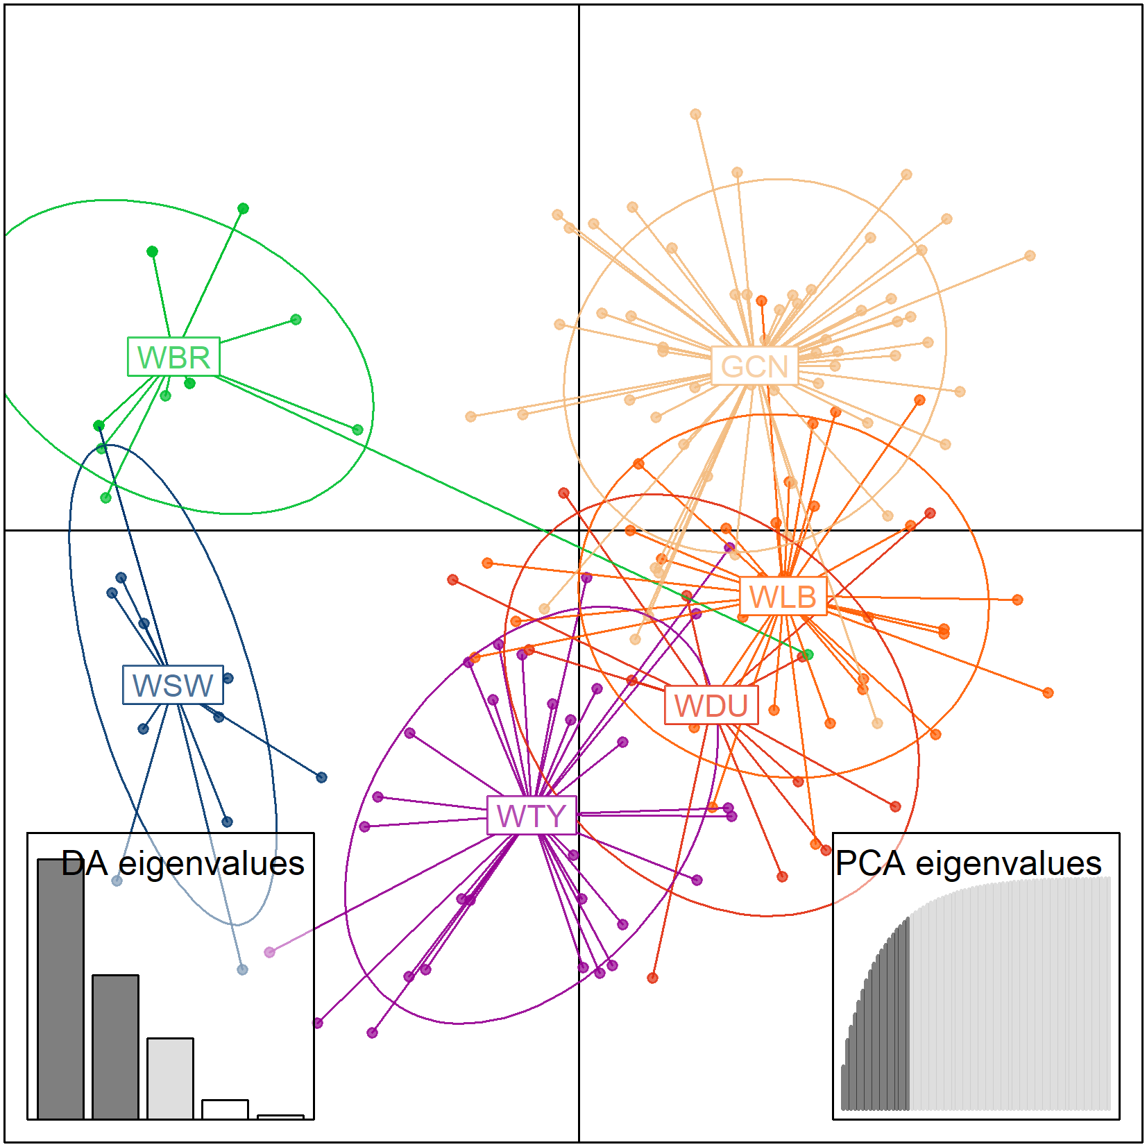
Figure 2. A visualisation of the genetic constitution of tested mussel populations using a Discriminant Analysis of Principal Components (DAPC) with a RedGreenBlue colour transformation (Jombart et al. 2010). Equal or similar colours reflect the same or similar genetic constitution of a population. Courtesy of Geist & Kuehn (2025).
2.iv. Quantifying juveniles for release
The final stage of selection should involve an exhaustive survey of all potential donor populations that had sufficient genetic diversity. This is a process of counting the total population sizes of all age cohorts and calculating an average length from measured representative and random samples. Measurements can be made using callipers or taking a photograph of the sample individuals next to a scale and using software such as ImageJ to calculate the lengths. It is recommended that juvenile mussels should be released at a size of > 15 mm to maximise their chances of survival, but also to meet release target numbers and get mussels into the river on schedule (Lavictoire & West, 2024). Additionally, at this length, the mussels are relatively easy to monitor; they can be tagged with a vinyl number tag for identification, as well as a Passive Integrated Transponder (PIT) tag. PIT tags are small tracking devices that allow the quantification of mussel retention at release sites. A PIT scanner device can be passed over the riverbed, and if a tagged mussel is detected, it will record the mussel’s unique ID.
Depending on the release strategy of a project, the number of mussels to be released each year should be confirmed. This can provide the minimum target number of mussels > 15 mm in length that should be propagated and ready for that year. For example, the R4ever Kent is to release 4000 mussels total, 3000 before the project end of 2027, and a further >1000 in the following years of ‘After LIFE’. See Table 2.
Table 2. The release strategy of the R4ever Kent project, detailing the number of juvenile mussels to be released each year.
Release Year | Number to be released
2025 | 1000
2026 | 1000
2027 | 1000
2028 < (After LIFE) | 1000 <
The results of the R4ever Kent exhaustive surveys concluded that of the Tyne, Clun and Irt populations, the Tyne would not have sufficient individuals for the timeframe; they failed to release in 2022 and therefore an entire cohort would be missing. Clun and Irt populations both had enough individuals growing through the systems to meet this 4000-mussel target. The decision was then made for the Clun to be the donor population, owing to their ability to encyst onto both salmon and brown trout host fish which will hopefully maximise their chances of successful reproduction in the river Kent in the future. Moreover, the river Irt is currently subject to large-scale restoration and mussel reinforcements through a partnership project between the FBA and West Cumbria Rivers Trust, funded by Biffa Award (Lavictoire and West, 2024). Hence, propagated Irt mussels can find a home in their native river. By contrast, the condition of the river Clun in Shropshire is extremely poor (Environment Agency, 2014) and not fit for propagated mussels to be reinforced there within the next 10 years. Fortunately, this means that the FBA’s propagated Clun mussels are in need of an alternate river to be released in, or they will remain in captivity indefinitely.
- Conclusion
With the native river Kent FPM population being critically low, the R4ever Kent project tasked the FBA with determining whether propagated mussels from an alternate UK river would be suitable as a donor population. The objective required the organisation to develop and follow a series of stages to ensure an appropriate population was selected to maximise the long-term success and viability of river Kent FPM. This document was produced in conclusion of these stages, implementing necessary improvements and changes to offer a detailed, best-practice guide for other conservation projects with extremely low wild population sizes of FPM. The four stages of ‘catchment fish studies’, ‘encystment trials’, ‘genetics studies’ and ‘quantifying juveniles for release’ concluded in the identification of the Clun mussel population from Shropshire as the most suitable donor population. This population had a sufficient number of propagated juveniles growing in the SRC, good genetic diversity and low inbreeding, as well as an ability to encyst (and produce viable offspring) on both Atlantic salmon and brown trout, which are distributed throughout the Kent catchment. Breeding from this group continues, giving confidence that the targeted 4000 juvenile mussels will be released by 2028.
- References
Bakshi, B., Bouchard, R.W., Dietz, R., Hornbach, D., Monson, P., Sietman, B., Wasley, D. (2023). Freshwater Mussels, Ecosystem Services, and Clean Water Regulation in Minnesota: Formulating an Effective Conservation Strategy. Water 15, 2560. https://doi.org/10.3390/w15142560
Cosgrove, P., Watt, J., Hastie, L., Sime, I., Shields, D., Cosgrove, C., Brown, L., Isherwood, I., Bao, M. (2016). The status of the freshwater pearl mussel Margaritifera margaritifera in Scotland: extent of change since 1990s, threats and management implications. Biodivers Conserv 25, 2093–2112. https://doi.org/10.1007/s10531-016-1180-0
Dadswell, M., Spares, A., Reader, J., McLean, M., McDermott, T., Samways, K., Lilly, J. (2022). The Decline and Impending Collapse of the Atlantic Salmon ( Salmo salar ) Population in the North Atlantic Ocean: A Review of Possible Causes. Reviews in Fisheries Science & Aquaculture 30, 215–258. https://doi.org/10.1080/23308249.2021.1937044
Environment Agency. (2019). Electric fishing operations: equipment and working practices. chrome-extension://efaidnbmnnnibpcajpcglclefindmkaj/https://assets.publishing.service.gov.uk/government/uploads/system/uploads/attachment_data/file/806271/EA_electrofishing_SOP.pdfAccessed 19/02/2025.
Environment Agency and Natural England. (2014). River Clun SAC Nutrient Management Plan – FINAL. Retrieved from chrome-extension://efaidnbmnnnibpcajpcglclefindmkaj/https://assets.publishing.service.gov.uk/media/5a7d52ce40f0b60a7f1a9d11/River_Clun_NMP_v6_FINAL_ISSUED_231014.pdf. Accessed 25/02/2025.
Farrell, M.J., Park, A.W., Cressler, C.E., Dallas, T., Huang, S., Mideo, N., Morales-Castilla, I., Davies, T.J., Stephens, P. (2021). The ghost of hosts past: impacts of host extinction on parasite specificity. Phil. Trans. R. Soc. B 376, 20200351. https://doi.org/10.1098/rstb.2020.0351
Geist, J. (2010). Strategies for the conservation of endangered freshwater pearl mussels (Margaritifera margaritifera L.): a synthesis of Conservation Genetics and Ecology. Hydrobiologia 644, 69–88. https://doi.org/10.1007/s10750-010-0190-2
Geist, J., Bayerl, H., Stoeckle, B.C., Kuehn, R. (2021). Securing genetic integrity in freshwater pearl mussel propagation and captive breeding. Sci Rep 11, 16019. https://doi.org/10.1038/s41598-021-95614-2
Geist, J., Kuehn, R. (2005). Genetic diversity and differentiation of central European freshwater pearl mussel ( Margaritifera margaritifera L.) populations: implications for conservation and management. Molecular Ecology 14, 425–439. https://doi.org/10.1111/j.1365-294X.2004.02420.x
Geist, J., Kuehn, R. (2025). Population genetic analyses of endangered freshwater
pearl mussel (Margaritifera margaritifera) in England. Technical report to the Freshwater Biological Association.
Geist, J., Söderberg, H., Karlberg, A., Kuehn, R. (2010). Drainage-independent genetic structure and high genetic diversity of endangered freshwater pearl mussels (Margaritifera margaritifera) in northern Europe. Conservation Genetics 11, 1339–1350. https://doi.org/10.1007/s10592-009-9963-4
Geist, J., Stoeckle, B. (2021). Genetic characterization of captive‐bred pearl mussel juveniles (Margaritifera margaritifera) and their parent broodstock (Cumbria, Great Britain). Technical report to the Freshwater Biological Association.
Hastie, L.C., Cosgrove, P.J., Ellis, N., Gaywood, M.J. (2003). The Threat of Climate Change to Freshwater Pearl Mussel Populations. AMBIO: A Journal of the Human Environment 32, 40–46. https://doi.org/10.1579/0044-7447-32.1.40
Jombart, T., Devillard, S., Balloux, F. (2010). Discriminant analysis of principal components: a new method for the analysis of genetically structured populations. BMC Genet 11, 94. https://doi.org/10.1186/1471-2156-11-94
Lavictoire, L., Moorkens, E., Ramsey, A.D., Sinclair, W., Sweeting, R.A. (2016). Effects of substrate size and cleaning regime on growth and survival of captive-bred juvenile freshwater pearl mussels, Margaritifera margaritifera (Linnaeus, 1758). Hydrobiologia 766, 89–102. https://doi.org/10.1007/s10750-015-2445-4
Lavictoire, L., West, C. (2024). Population Reinforcement of the Endangered Freshwater Pearl Mussel (Margaritifera margaritifera): Lessons Learned. Diversity 16, 187. https://doi.org/10.3390/d16030187
Österling, E.M. (2015). Influence of host fish age on a mussel parasite differs among rivers: Implications for conservation. Limnologica 50, 75–79. https://doi.org/10.1016/j.limno.2014.11.001
Preston, S.J., Keys, A., Roberts, D. (2007). Culturing freshwater pearl mussel Margaritifera margaritifera : a breakthrough in the conservation of an endangered species. Aquatic Conservation 17, 539–549. https://doi.org/10.1002/aqc.799
Taeubert, J.-E., Geist, J. (2017). The relationship between the freshwater pearl mussel (Margaritifera margaritifera) and its hosts. Biol Bull Russ Acad Sci 44, 67–73. https://doi.org/10.1134/S1062359017010149
Vaughn, C.C. (2018). Ecosystem services provided by freshwater mussels. Hydrobiologia 810, 15–27. https://doi.org/10.1007/s10750-017-3139-x
Vaughn, C.C., Hakenkamp, C.C. (2001). The functional role of burrowing bivalves in freshwater ecosystems. Freshwater Biology 46, 1431–1446. https://doi.org/10.1046/j.1365-2427.2001.00771.x
Verma, A.K., Rahman, A., Hussain, S., Singh, N.S. (2025). Freshwater Mussels as Multifaceted Ecosystem Engineers: Insights into Their Ecological Importance, Bioindication, and Economic Contributions. https://doi.org/10.20944/preprints202501.0085.v1
Wacker, S., Larsen, B.M., Karlsson, S., Hindar, K. (2019). Host specificity drives genetic structure in a freshwater mussel. Sci Rep 9, 10409. https://doi.org/10.1038/s41598-019-46802-8

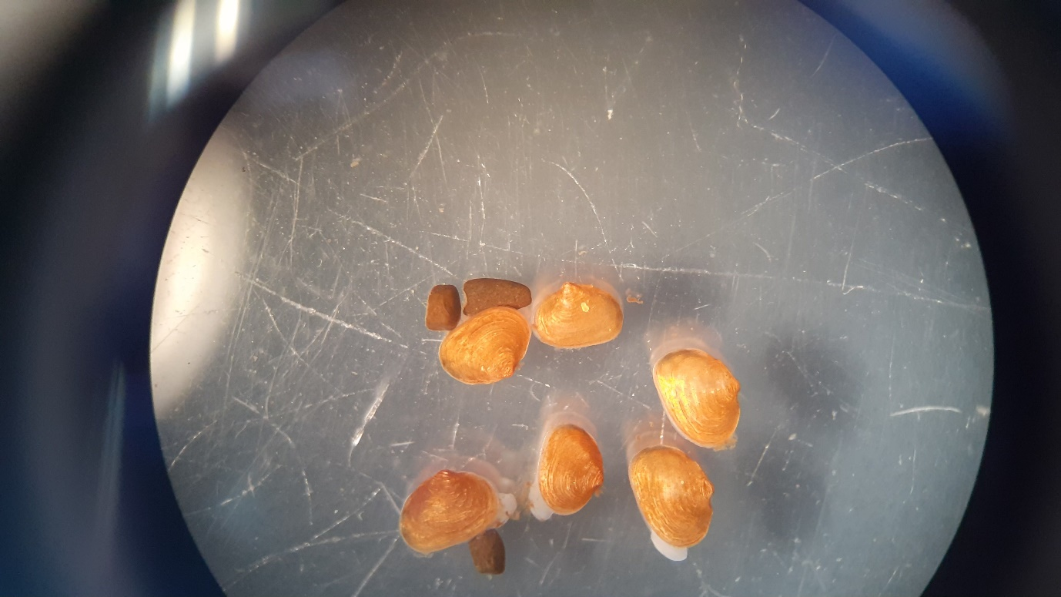
The Freshwater Biological Association
The Freshwater Biological Association
The Ferry Landing
Far Sawrey, Ambleside
Cumbria, LA22 0LP, United Kingdom
Web site: www.fba.org.uk
Email: info@fba.org.uk

https://imagej.net/ij/
https://hallprint.com/fish-tag-products/2014/8/26/glue-on-shellfish-tags
https://fishbio.com/beginners-guide-pit-tags/

